Johnny Li

November 12, 2018

EEL3111C

Lab 10 Write Up

**Abstract**

The circuit built for the final project was an audio amplifier that modified an audio source, a 19-second-long jingle, to be played on a speaker. The circuit design was based upon the previous labs done throughout the semester. The first component in the circuit design is an active high pass filter. The active high-pass filter was used to filter out the lower voltage signal from the audio source, preventing the lower audio voltage signals from passing through the circuit and generating unwanted noise. The filtered signal then moves to the variable gain op amp where the audio voltage is magnified by a gain created by altering the equivalent resistance, through the potentiometer, on the op amp. This is done so that audio voltage is magnified from millivolts to volts and be able to be picked up by the speakers at the output buffer. The output buffer stage is used to buffer the output from the variable op amp so that jingle could be heard on the speakers. Additionally, the magnified audio output voltage is also used in the peak detector. The peak detector compared the audio output voltage with the reference voltages, 4V and 1V, where the LEDs lit up when the gain of the variable op amp was enough to magnify the audio source voltage to be greater than the reference voltages. The peak detector is a visual output of when the audio output voltage reached a desired range between the reference voltages.

**Procedure**

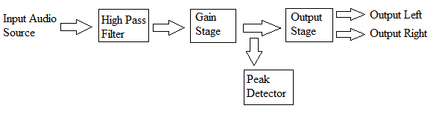

Figure 1: This block diagram gives an illustration of the different concepts components in the circuit design for the final project.

High Pass Filter Stage

At the high-pass filter stage, an active high-pass filter is implemented with a gain of 1 upon the audio input voltage source. An op amp is used as required in an active filter design, but the resistors were chosen to prevent any significant gain from being generated so the resistor have equivalent resistance. For the output of the high pass filter to fall within the required frequency bounds a capacitor of .1 micro farad was placed in between the audio input source and the active high-pass filter. The capacitor, which was quite large, is used to reduce the frequency outputted from the audio input source that enters the active high-pass filter.

Gain Stage

At the gain stage, a variable gain op-amp is implemented to magnify the output voltage from the active high-pass filter from micro-volts to volts. An op amp is used as required in a variable gain op-amp design and since the gain had to vary a potentiometer was employed to manually alter the gain which also alter the magnification of the output voltage from the active high-pass filter. The potentiometer can have a resistance of 10k ohms and feedback resistor has a resistance of 1Meg ohms, generating a possible gain of 100 at the inverting terminal of the op amp. This allowed for the 10mv output voltage from the active high-pass filter to be magnified between the range of 1V to 5V where the output can be altered to the desired range.

Output Stage

At the output stage, an output buffer is implemented take the magnify output from the gain stage and buffer the voltage, so that the speakers could play the jingle. The output buffers only used an op amp in the design and no resistors because the op amp’s internal resistance was enough to buffer the output voltage from the gain stage for the speakers. In the output stage the voltage from the gain stage is split into two branches, one for the left speaker and the other for the right speaker. The output stage is simple as it has minimalistic components involved, only used the input and output of an op amp with no resistors.

Peak Detector

At the peak detector stage, comparators are implemented to compare the magnify output voltage from the gain stage to the reference voltage generated by the resistor ladder to determine when the clipping started. When the output voltage passes a certain reference, 1V and 4 V, the LEDS would light up to indicate that the desired range was reached. If the no reference LED were to light up, it is an indication that clipping has occurred. The resistor ladder used to generate the 1V and 4V references is different from that of the previous lab as it only had a 5V voltage source to ground range, rather than the 5V to -5V sources range in the previous lab. This was accomplished with a 1k ohm resistor, 3.3k ohm resistor, and 1k ohm resistor in the ladder, this generated a reference voltage close to 1V and 4V but not exactly those values.

**Results**

1. Circuit diagram of the final circuit.

Figure 2: A LTSpice model of the circuit designed in the final project.

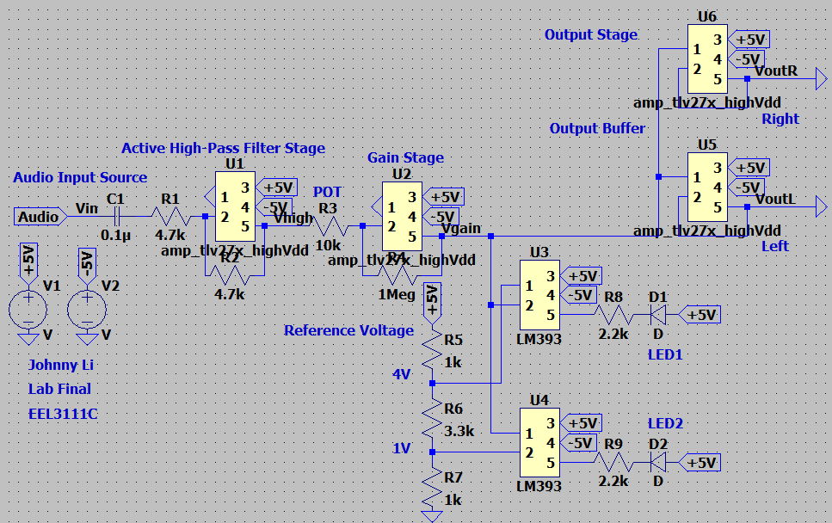

2. Parts List

Table 1: The table contains the parts used in the final circuit and the total price of the components used within the circuit.

|  |  |  |  |
| --- | --- | --- | --- |
| Parts | Quantity | Price ($) | Total Price ($) |
| 0.1 uF capacitor | 1 | 0.23 | .23 |
| 1k resistor +/- 5% | 2 | 0.10 | 0.20 |
| 2.2k resistor +/- 5% | 2 | 0.10 | 0.20 |
| 3.3k resistor +/- 5% | 1 | 0.10 | 0.10 |
| 4.7k resistor +/- 5% | 2 | 0.10 | 0.20 |
| 1M resistor +/- 5% | 1 | 0.10 | 0.10 |
| Potentiometer 10k | 1 | 0.80 | 0.80 |
| LED | 2 | 0.21 | 0.42 |
| LM393 | 2 | 0.80 | 1.60 |
| TLV272 | 4 | 0.62 | 2.48 |

3. Figure 3: Plot of the input (CH1+) and (CH2+) output (either buffered output) of jingle19 file.

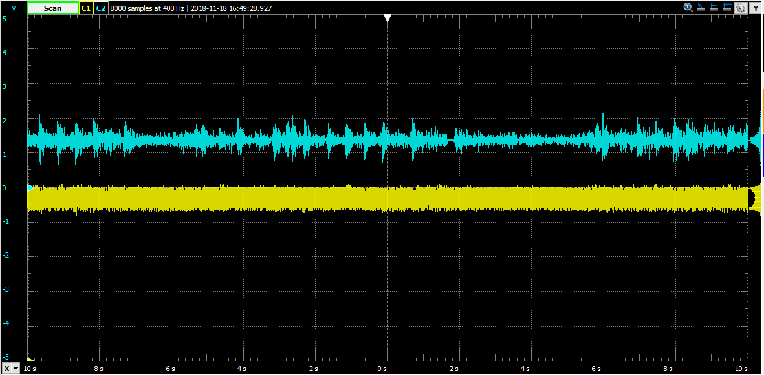

4. Figure 4: Plot the network response from the input to the output of either buffer with an offset of 500 mV and an amplitude of 10 mV.

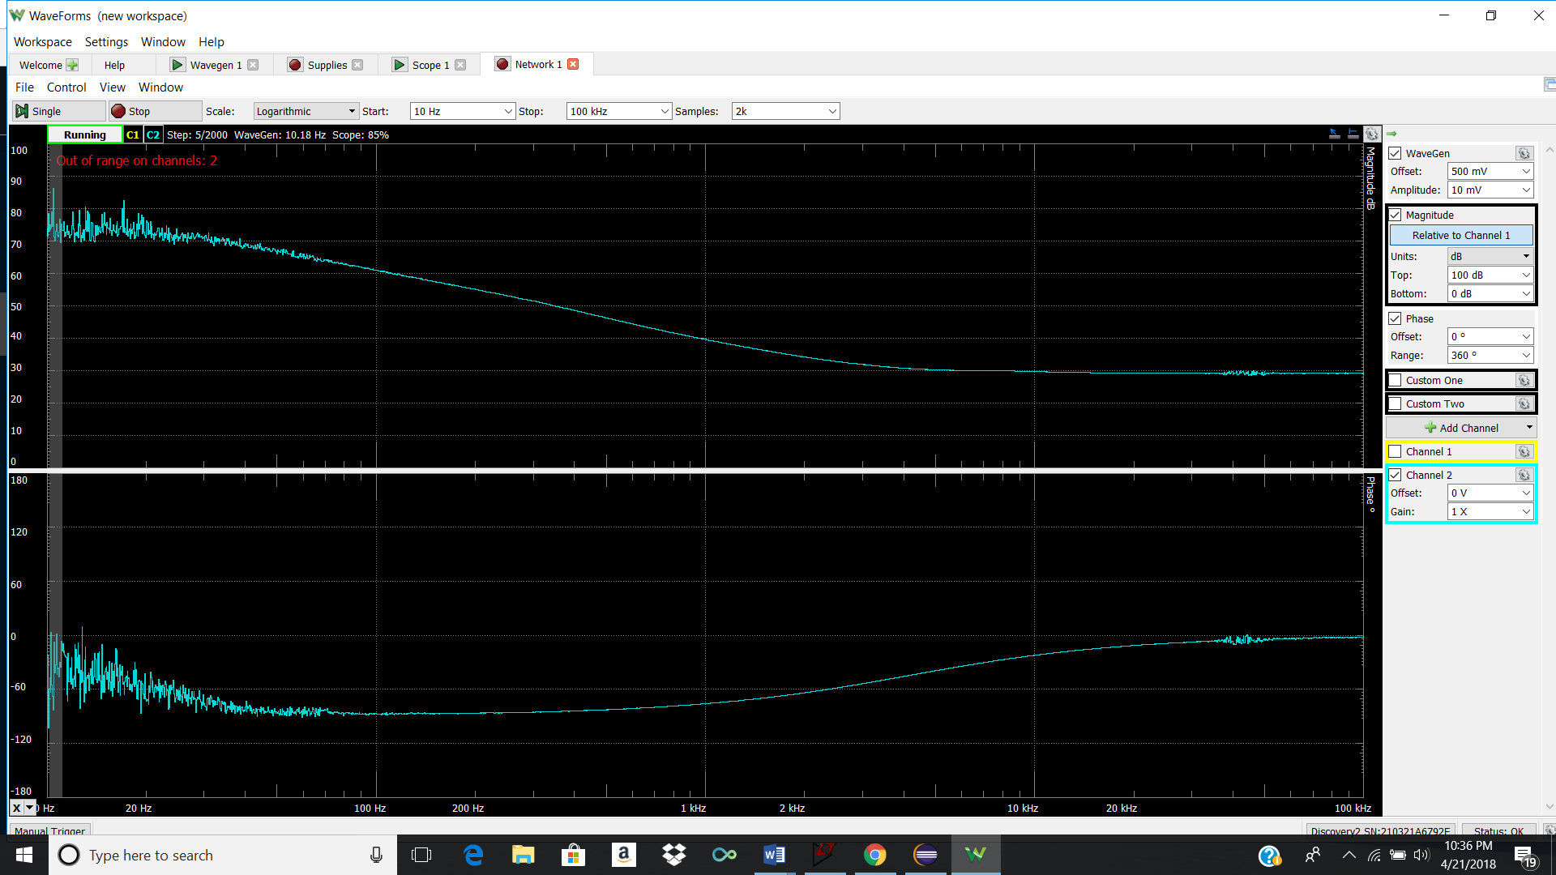

5. Figure 5: The graph of the output using the spectrum tool with the 1 kHz, 10 mV and 0.5V offset sine wave.

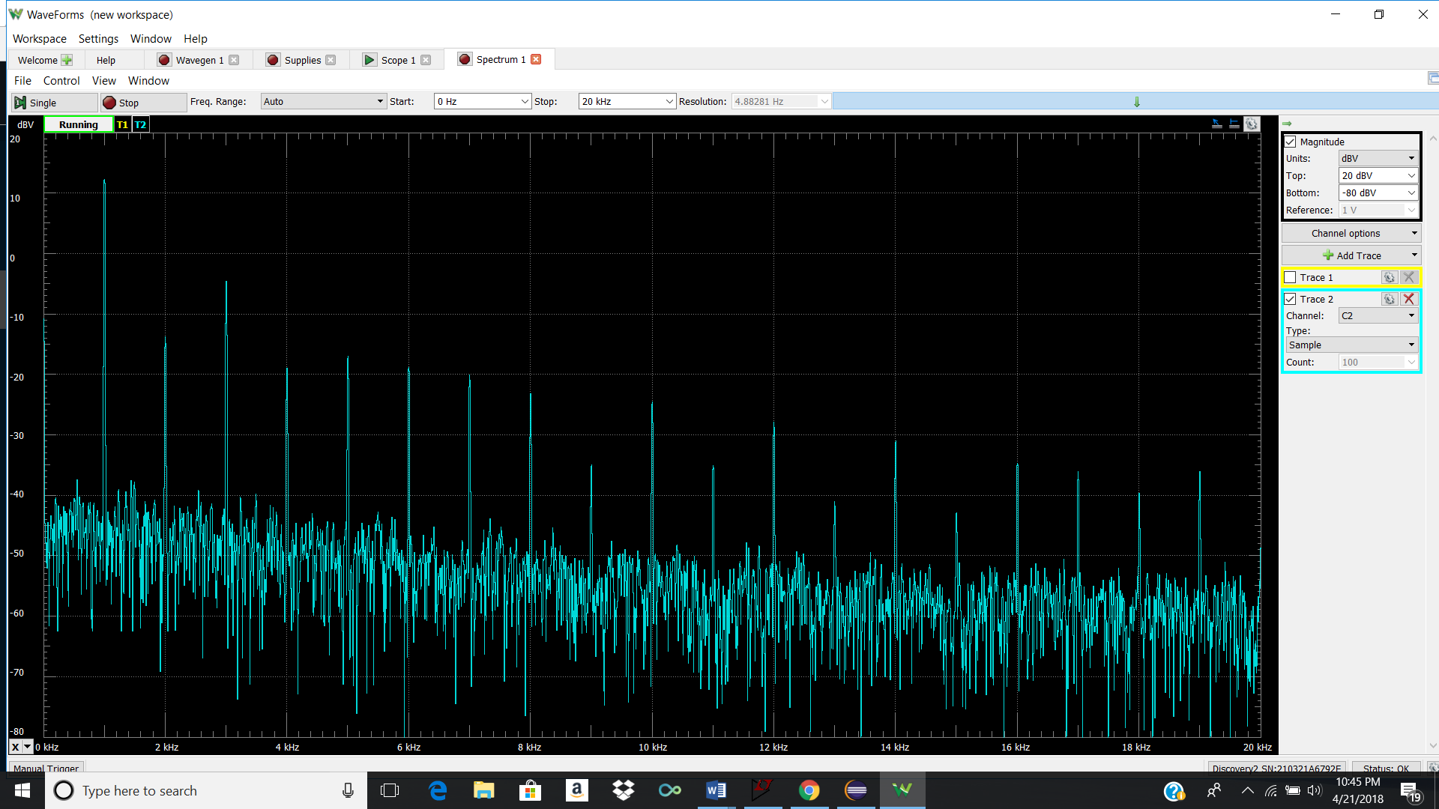

**Conclusion:**

In conclusion, the final project circuit design was an audio amplifier that magnified the audio voltage of the inputted audio signal until it could be heard on the speakers. The circuit performed the task of manipulating the audio signal voltage till the proper dB had been achieved and processed through the speaker, but the design did have some errors. The first error that popped out was the resistors used for the reference voltages which were not exactly in the proper ratios, being slightly lower than 4V and higher than 1V reference, which influenced some of the values on the plotted results. The second error with the circuit design is that the resistors did have tolerance, thus the values returned were not ideal. Excluding the errors, the circuit performed at optimally and displayed the correct audio and LED sequences when the gain was varied. This can be seen when the gain was increased to the point of voltage clipping where the two LEDS lit up, giving a visual result for the clipping voltage. An improvement for the circuit could have been to use the proper resistors to obtain the preferred ratios for the reference voltages.